**Name: Mustafa Hassan**

**ID: FA21-BSCS-0030**

**COURSE: AI-LAB**

**INSTRUCTOR: MISS FOZIA KHAN**

**LAB-TASK-04**

create a folder name as Task04 in Drive H/ Downloads. Move to that directory and compile the file.

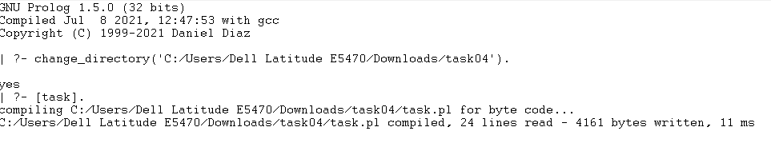

1. Create the following Facts.

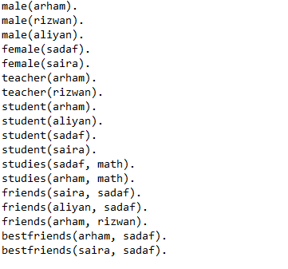

2. create the following rules.

1. Rules for mutual friends.



1. Rules for classfellow.



1. Rules for getting good grades on the basis teacher and student relationship status.



1. Rules Mutual Bestfriends.



3. Verify each rule by giving some queries.

